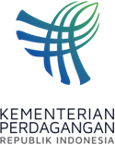
PRESS RELEASE
Public Relations Bureau
Bldg. I Fl. 2, Jl. M.I. Ridwan Rais No. 5, Jakarta 10110 Phone: 021-3860371/Fax: 021-3508711
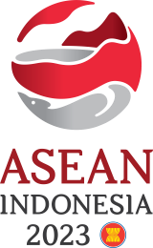
www.kemendag.go.id

The 12th AEM-Russia Consultation Meeting,
Trade Minister Zulkifli Hasan: Strengthen Implementation of ASEAN Trade and Investment Cooperation

Semarang, 21 August 2023 – ASEAN and the Russian Federation will strengthen the implementation of trade and investment cooperation. This was raised in the 12th ASEAN Economic Minister (AEM) consultation meeting with Russia on Monday (21/8) in Semarang, Central Java.

The meeting chaired by the Minister of Trade Zulkifli Hasan was part of the series of the 55th AEM Meeting and Related Meetings held on 17-22 August 2023. At the meeting, the Russian delegation was led by the Director General of the Department of Multilateral Economic Cooperation and Special Projects of the Ministry of Economic Cooperation of the Russian Federation, Nikita Kondratyev.

"This is the 10th meeting on day 3 of the 55th AEM series in Semarang. The meeting discussed cooperation on the implementation of ASEAN-Russia trade and investment, such as the ASEAN Russia e-commerce workshop, agricultural supplies from Russia to ASEAN, increasing the tourism sector; connectivity via direct flights between Moscow-Bali; digital security, especially e-payments; and the development of creative animation," explained Trade Minister Zulkifli Hasan.

Trade Minister Zulkifli Hasan continued, the meeting also noted the implementation of the Cooperation Program between ASEAN and the Eurasian Economic Commission (EEC) 2023- 2025. For example, digital transformation seminars in the EEC and ASEAN, EEC-ASEAN business dialogues, and side events related to Sustainable Development Goals (SDGs).

"ASEAN-EEC economic initiatives and cooperation are aimed at post-pandemic economic recovery, particularly strengthening supply chains, food security, sustainable development, and economic integration between ASEAN and EEC," said Trade Minister Zulkifli Hasan.

In his opening remarks, Trade Minister Zulkifli Hasan said that the Russian Federation is an important trade partner for ASEAN. Russia is ranked the 9th in terms of largest investment in ASEAN in 2022 among ASEAN Dialogue Partners and ranks 9th in terms of goods trade balance.

"Seeing the important roles of ASEAN and Russia for regional and global trade, we expect support for Indonesia's Chairmanship of ASEAN in 2023. This meeting is an important momentum to strengthen ASEAN and Russian economies," added Trade Minister Zulkifli Hasan.

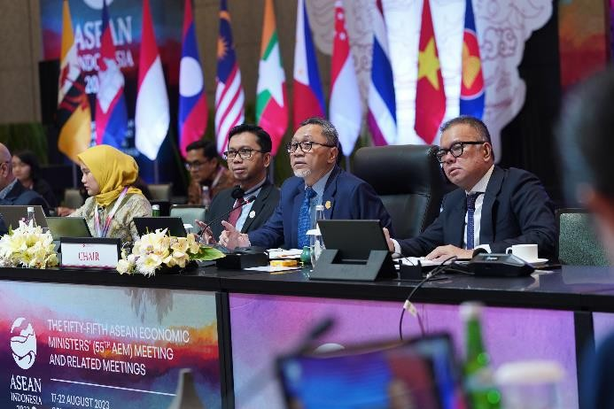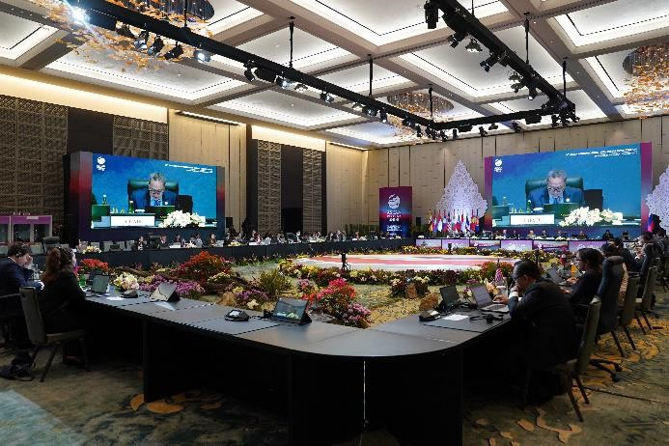
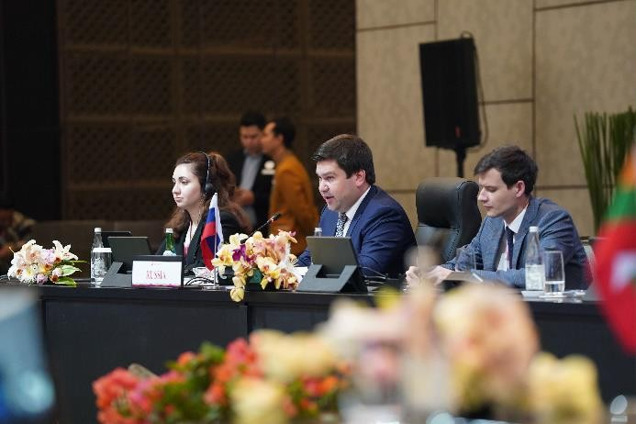
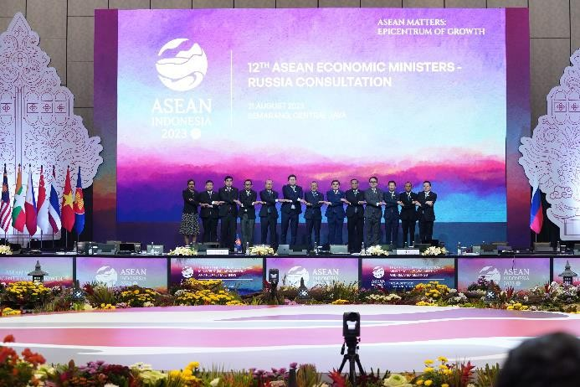

--end--

For further information please contact:  Ani Mulyati  Head of Public Relations Bureau Ministry of Trade  Email: pusathumas@kemendag.go.id | Dina Kurniasari  Director of ASEAN Negotiations  Directorate General of International Trade Negotiations Ministry of Trade  Email: asean@kemendag.go.id

